***Project-CI/CD Deployment for Spring-Boot Application.***

**Git Repository link**

**[:](: https://github.com/Avinash640/Phase5Project)** [https://github.com/Avinash640/Phase5Project](: https://github.com/Avinash640/Phase5Project)

**Developer Name:Avinash Sitaram Singh**

**DESCRIPTION:**

**Project Objective:**

***In this project building a CI/CD pipeline to demonstrate continuous deployment and host the application on AWS EC2 instance.***

**Following flow used:**

*• Eclipse*

*• GitHub*

*• Jenkins*

*• AWS EC2/ Virtual machine*

  Representing visually what we are doing here.

**

***Following steps are used while making a Project:***

***Eclipse: Creating / build the Spring boot Application inside an Eclipse workspace.***

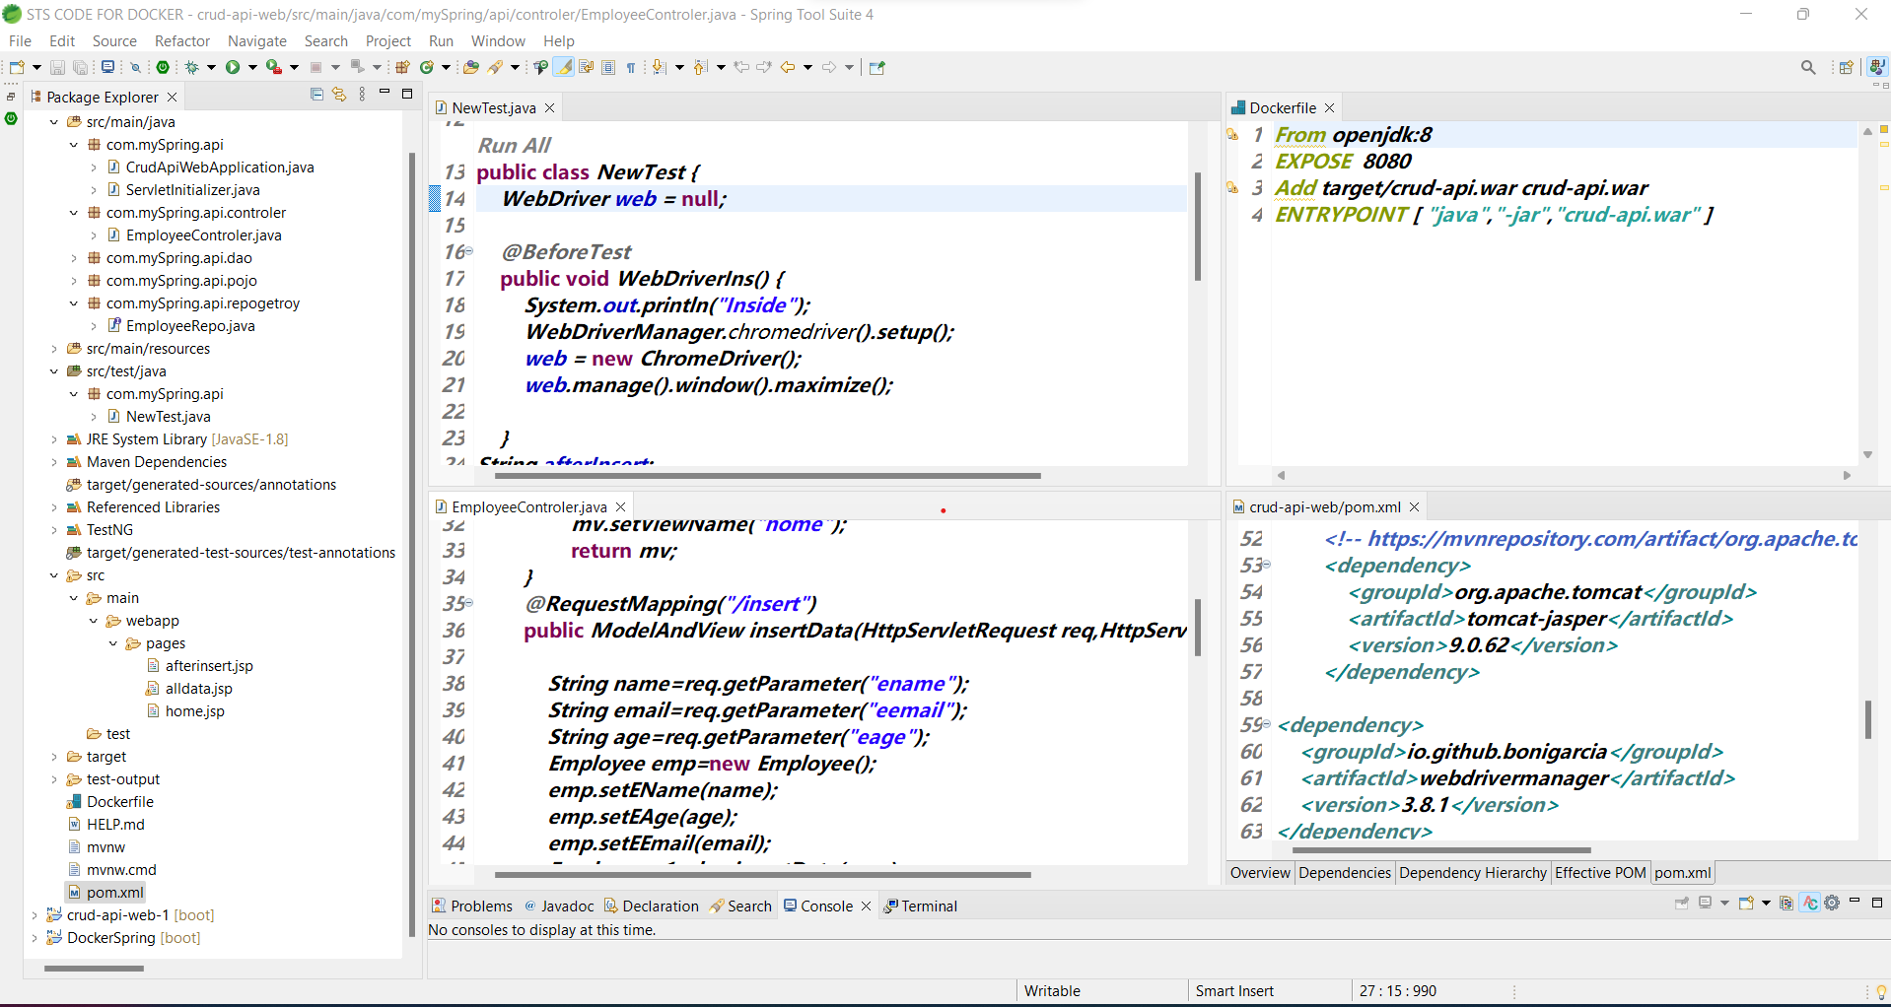

***Push the jar file into GitHub repository.***

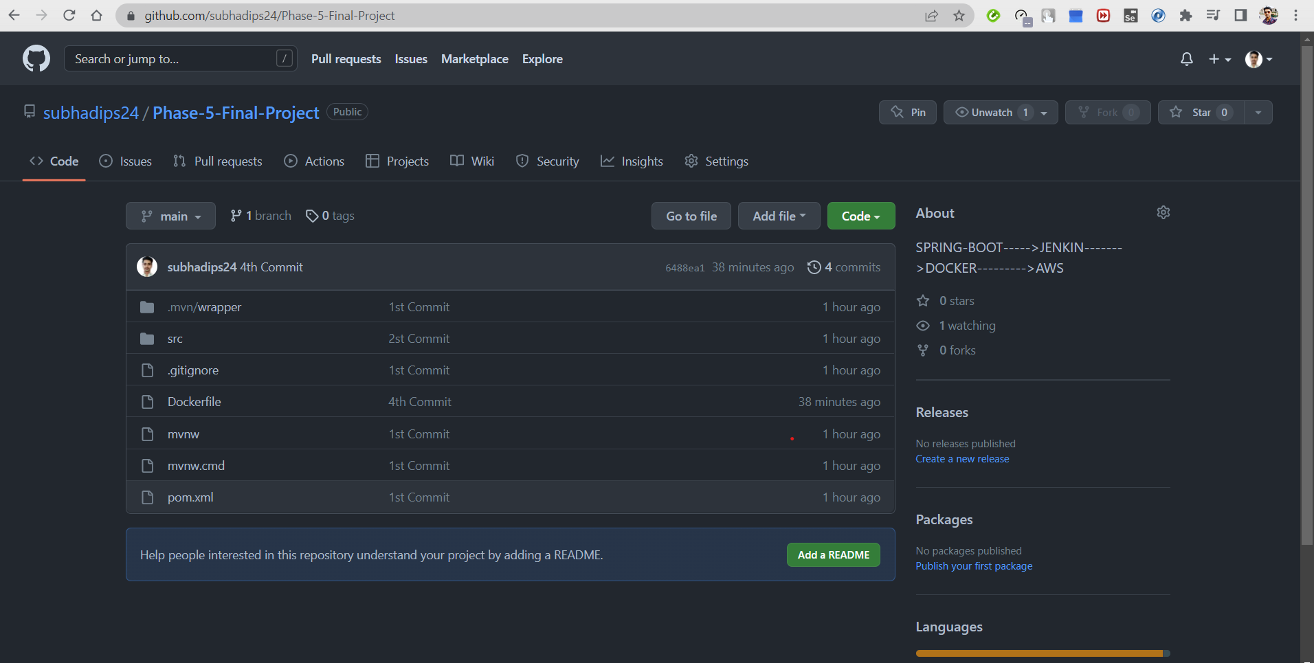

***JENKIN Work Place***

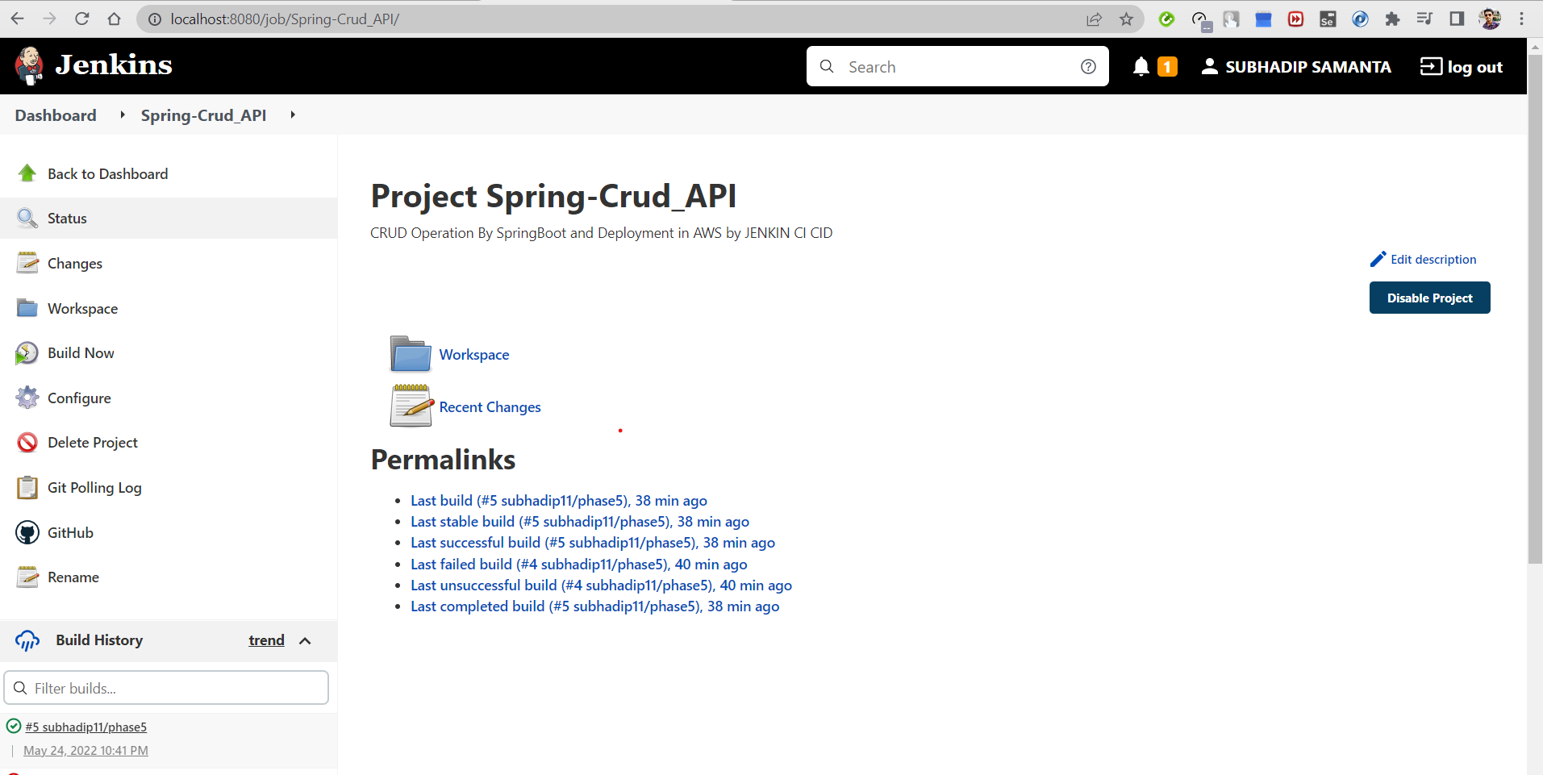

***Configuration***

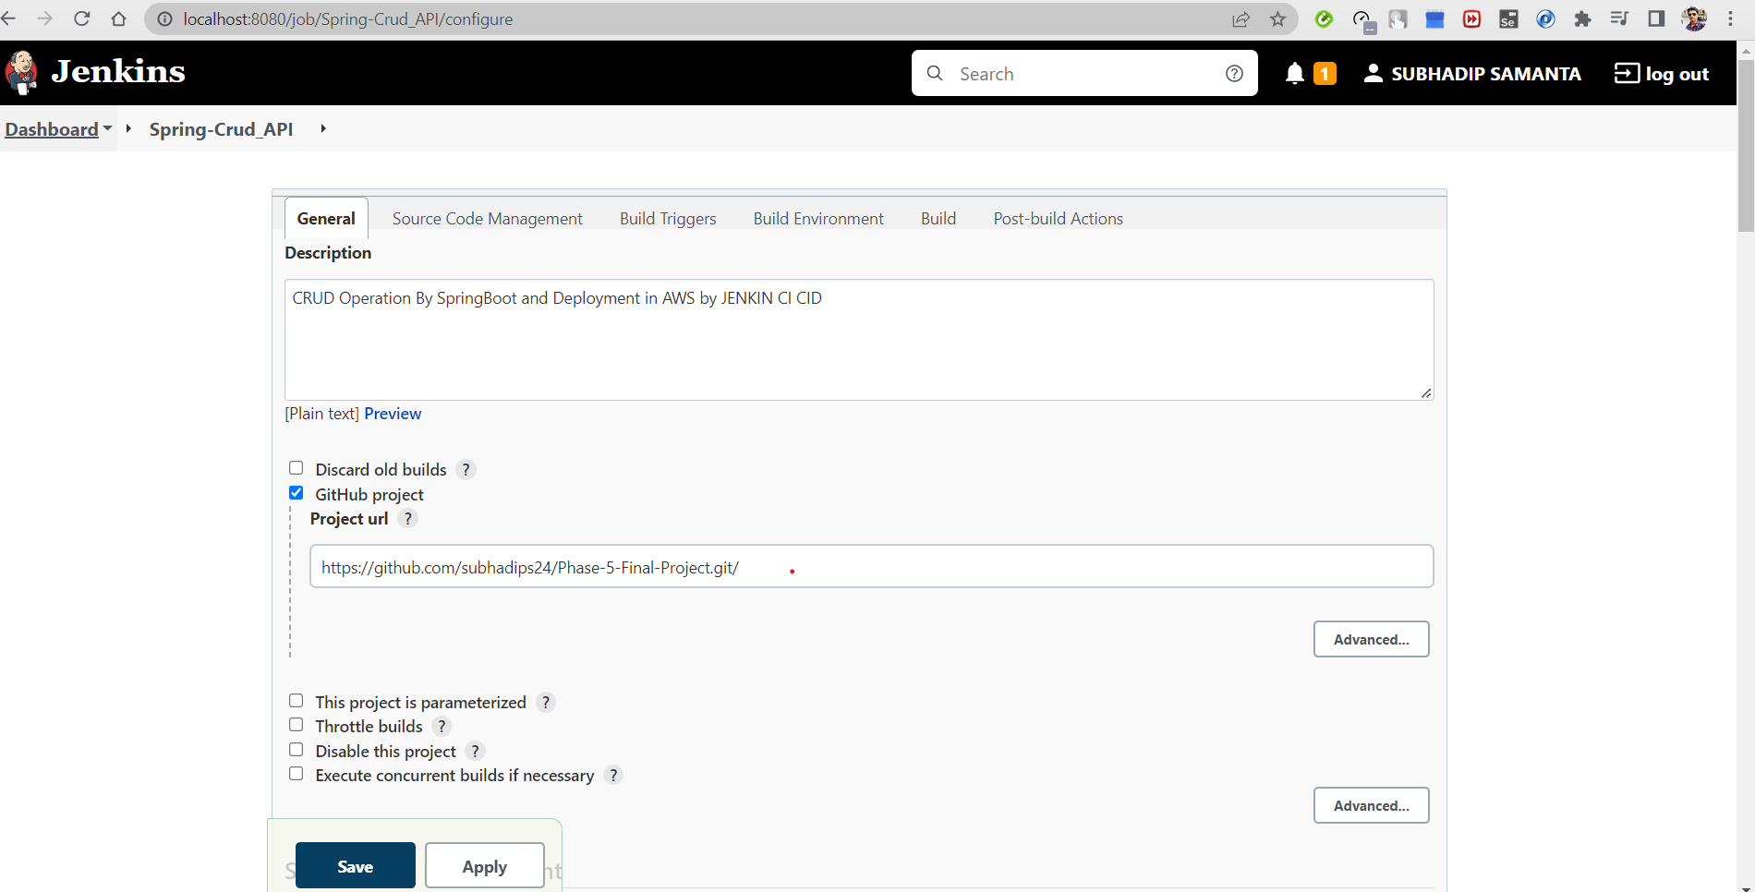

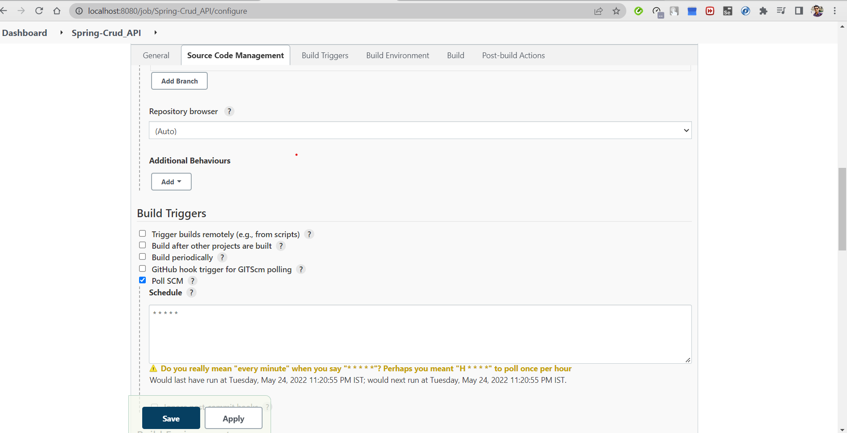

BUILD WAR FILE AND PUSH DOCKER

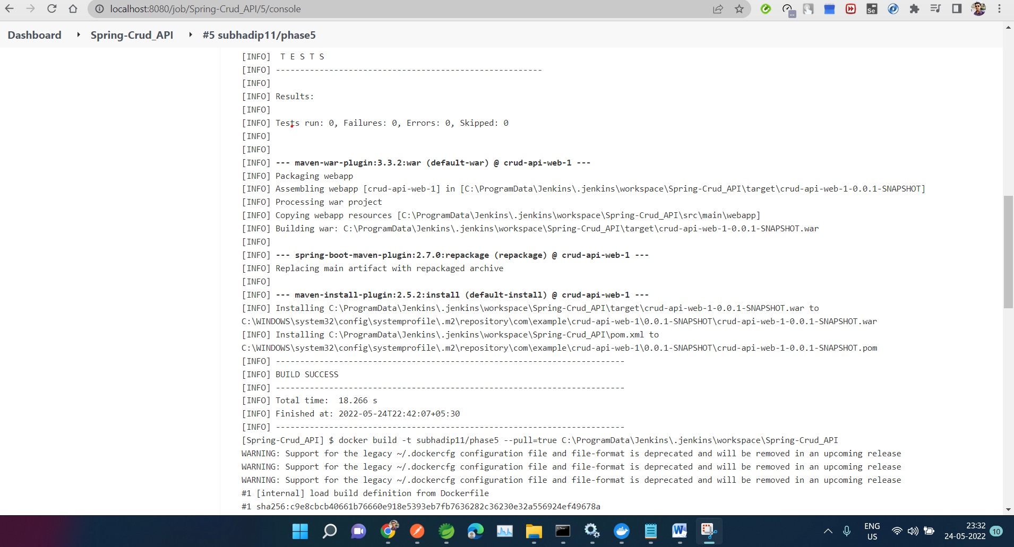

***DOCKER***

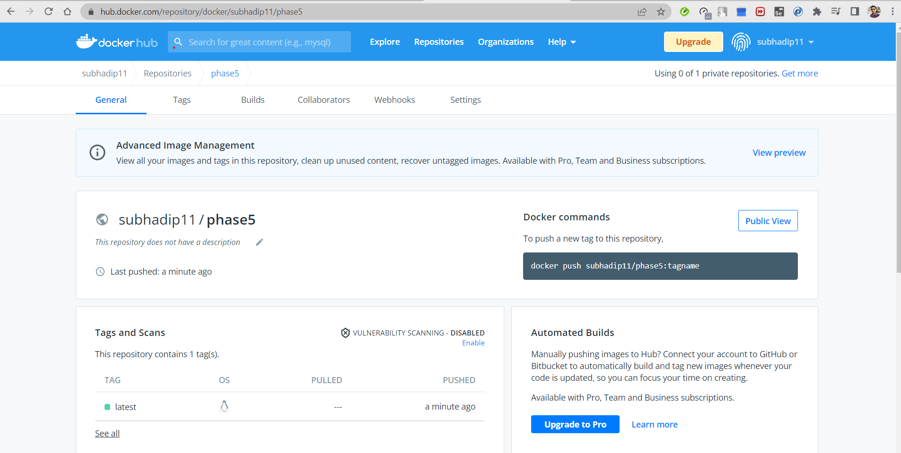

**AWS EC2**

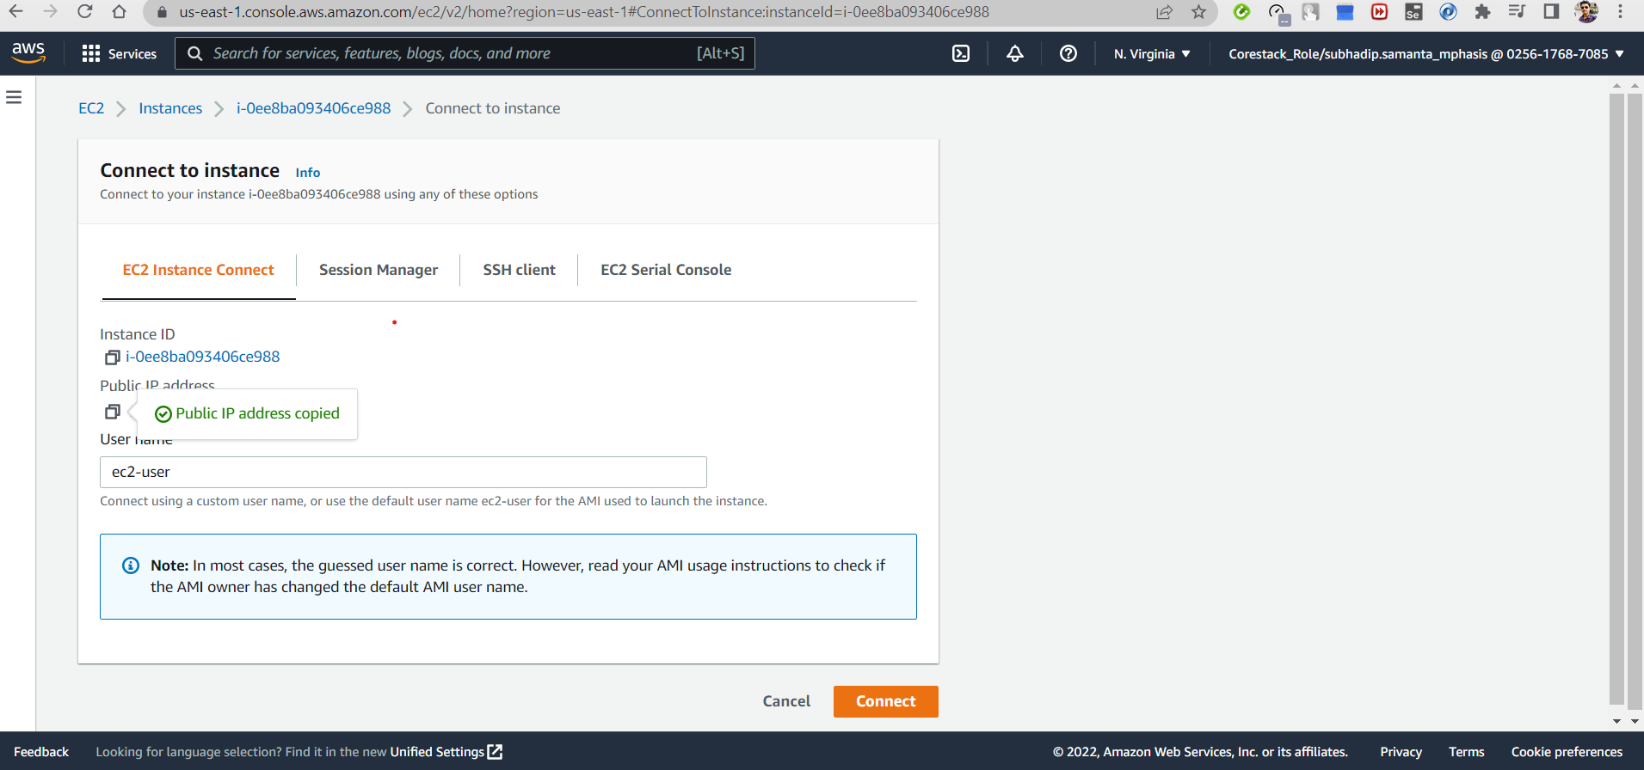

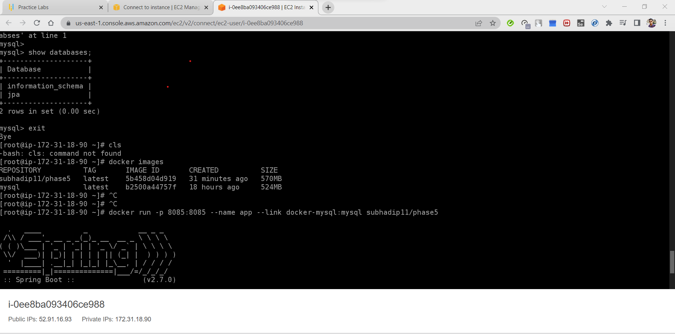

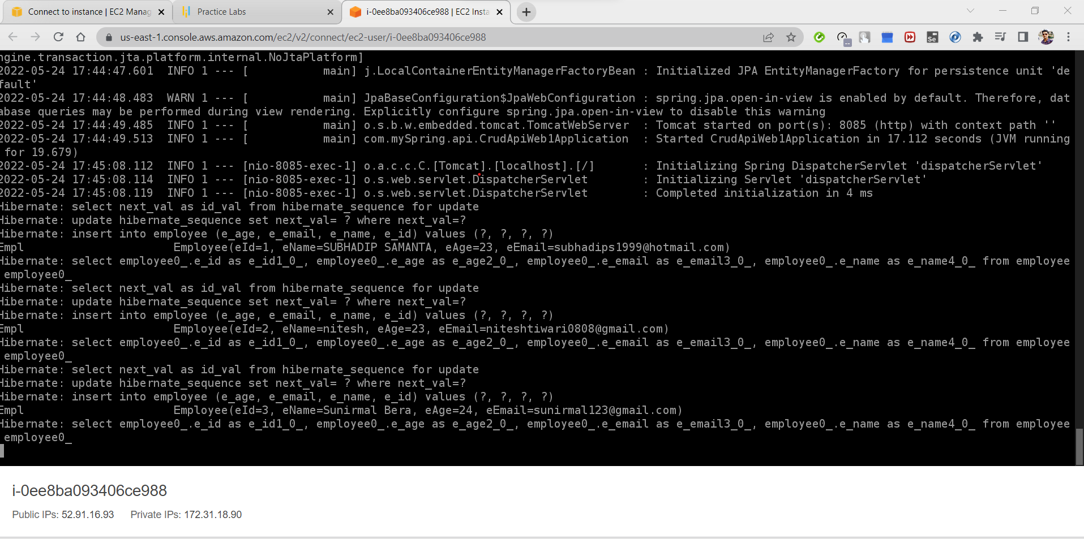

**OUTPUT RUN IN WEB**

